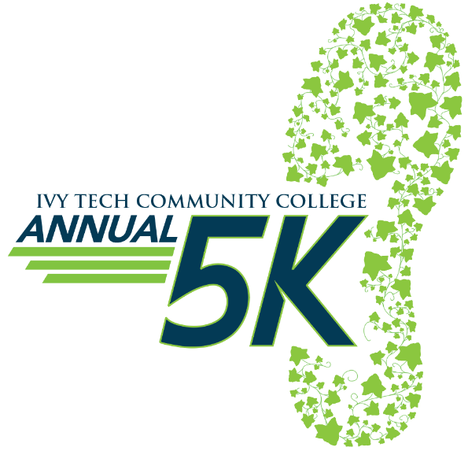**4th Annual Ivy Tech 5K Fun Run/Walk Registration Form**

**Presented by**

Event Location: Ivy Tech Community College, 8000 South Education Drive, Terre Haute, IN

Event Date/Time: Saturday, March 2, 2019- 1 mile Family Fun Run – 9:00 A.M.; 5K – 9:30 A.M.

Online Registration Available at ivytech.edu/5K or onsite the day of the event from 8:00-9:00 A.M.

Benefiting Ivy Tech Student Scholarship Fund

**All fields are required-** One form per registrant- Entries must be received by Friday, February 11th, 2019 to receive preferred t-shirt  
size. Entries received after this date will receive an adult large.

Additional t-shirts will be available for purchase day of the event for $15.

First Name ______________________Middle Initial _____ Last Name _____________________________

Street Address __________________________________________________________________________

City ________________________________________________State _________Zip__________________

E-mail _________________________________________________________________________________

|  |  |
| --- | --- |
| Early Registration  (Prior to Feb 11, 2019) | |
| Adult Registration | $20 |
| Student/Child | $15 |
| Late Registration  (After Feb 11, 2019) | |
| Adult Registration | $25 |
| All Students | $20 |

Contact the Ivy Tech Foundation for more information at:

(812)298-2450 or Email larnold52@ivytech.edu

Entry Fee (from selection above):___________

Make Checks Payable to: **Ivy Tech Foundation**

Please complete and sign this form, include your entry fee and mail to:

Ivy Tech Foundation

8000 South Education Drive

Terre Haute, Indiana 47802

Daytime Phone (___) __________Evening Phone (___) _______ Birth Date (xx/xx/xx) __________________

Team Name____________________________________________________________________________

Age on Race Day ______ Sex M F 1 Mile Family Fun Run 5K

**Adult Size** S M L XL XXL XXXL Youth Size S M L

Emergency Contact Person ____________________________Emergency Phone (___) __________

**Participant Assumption of Risk and Release**

**PLEASE READ AND SIGN THE FOLLOWING INFORMATION:**  I UNDERSTAND MY ENTRY IS NOT REFUNDABLE. I accept responsibility for the accuracy of the provided information, and I understand that if this information is illegible or incomplete, it will affect the results and event scoring. In consideration of your acceptance of my entry, I, intending to be legally bound for myself, and anyone entitled to act in my behalf, do hereby release and discharge Ivy Tech Community College and Ivy Tech Foundation and all other sponsors, contributors, volunteers and organizers from any liability arising from illness, injury and damages I may suffer as a result of my participation in the Ivy Tech Foundation, Annual 5K. By registering for the Ivy Tech Foundation, Annual 5K and signing this waiver, I willingly agree to receive e-mail information about other upcoming Ivy Tech events. I further grant permission to all of the foregoing to use any photographs, motion pictures, recordings or any other record of this event for any legitimate purpose. **I agree to a pay a $30 fee** if my timing chip is not returned to a volunteer or official race drop location. I have read the entry information provided and certify my compliance by my signature below. If participant is under 18 years old, I certify by my signature that the child has permission to participate, is in good physical condition and that officials may authorize emergency medical treatment in the event of an injury or illness.

p

kc

__________________________________ _______________ ______________________________________________ _______________

Participant’s Signature Date Parent/Guardian Signature (if Participant is under 18 years old) Date

INQUIRY ABOUT EVENT SPONSORSHIP AND PHOTO COPIES OF EVENT REGISTRATION ARE ENCOURAGED